Remove wrong GitHub credentials (Windows)
- Press Start
- Type: Credential Manager → open it
- Click Windows Credentials
- Find any entries like:
  - git:https://github.com
  - github.com
- Delete every one of them

Interaction using Clone and pull

C:\Users\CSE LAB\Downloads\VALLI\newone> git clone
C:\Users\CSE LAB\Downloads\VALLI\newone\project>git pull origin main
After pull
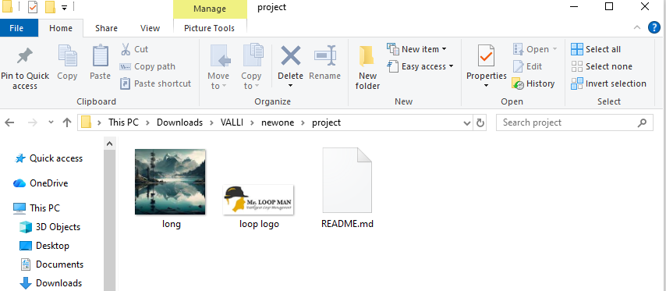
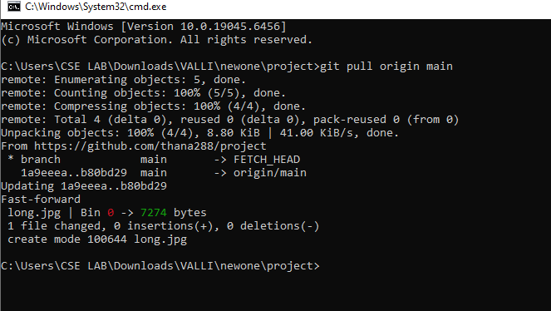

Github account creation
Steps to Create a GitHub Account
1. Open the GitHub Website
Go to: https://github.com/
2. Click on "Sign up"
You will find the Sign Up button at the top-right corner.
3. Enter Your Details
You must fill in the following:
Field Description
Email address Enter a valid email you use
Password Create a strong password
Username Create a unique username
Marketing emails Optional – choose Yes/No
4. Verify Your Account
GitHub may ask you to solve a puzzle or verify your email.
Go to your mailbox and click Verify Email.
5. Choose a Plan
Select a plan:
Free (best for students or beginners)
Paid plans (optional — for professional use)
Choose Free Plan to start.
6. Personalize Your Account (Optional)
GitHub will ask:
Your experience level
What you plan to build
Preferences
You can skip these or answer.
Your GitHub Account is Ready!

Now you can:
Create repositories

Upload code
Collaborate with others
Use Git with GitHub

EX.PR. 1.To initialize a Git repository and perform basic operations

1. Initialize a Git Repository
Syntax :gitinit
- This command initializes a new Git repository in the current directory.
- It creates a hidden folder .git/ that stores all repository data.

2. Check Repository Status
Syntax :git status
- Shows the current state of your working directory and staging area.
- Displays which files are modified, staged, or untracked.
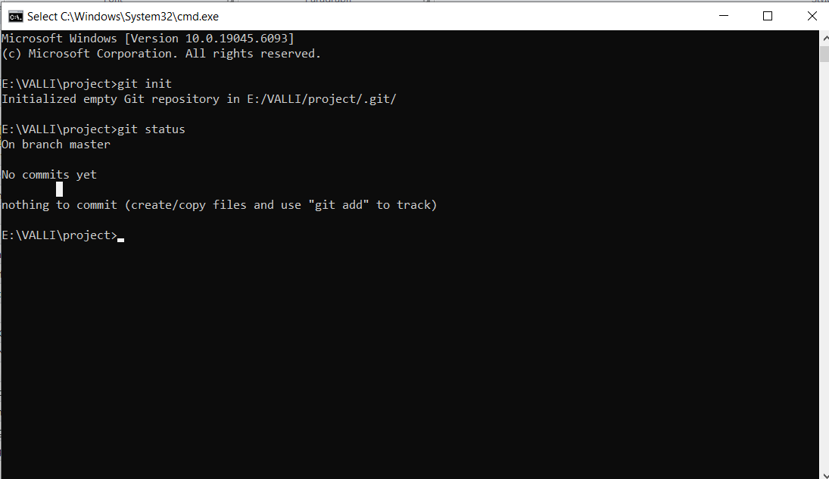

3. Add Files to the Staging Area
git add filename
or to add all files:
Syntax :git add.
- Moves files from the working directory to the staging area (ready to commit).
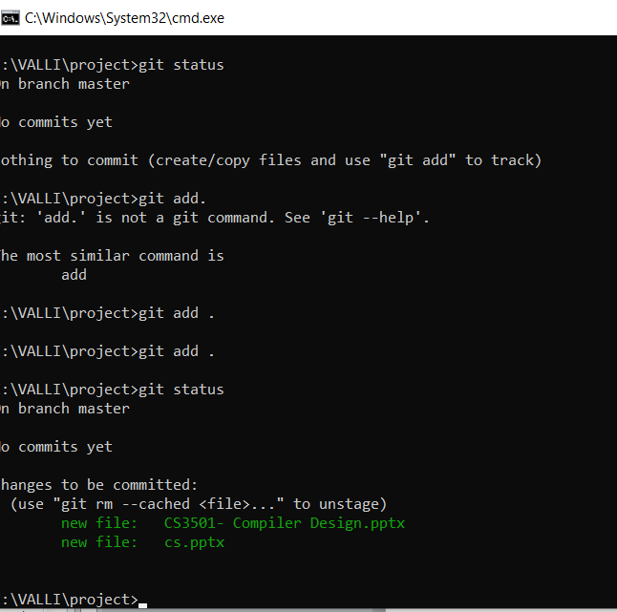

4. Commit the Changes
Syntax :git commit -m "Initial commit"
- Saves the staged changes permanently in the repository with a message.
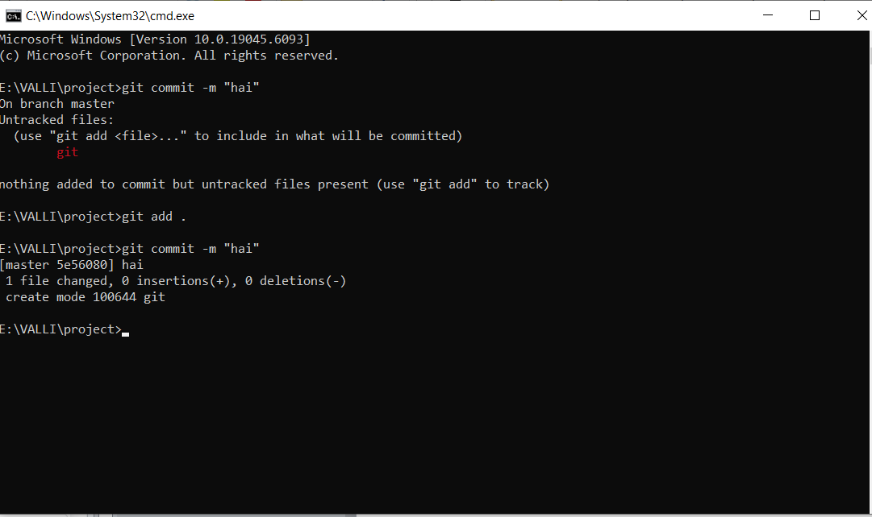

5. View Commit History
Syntax :git log
- Displays the list of commits with author, date, and commit message.
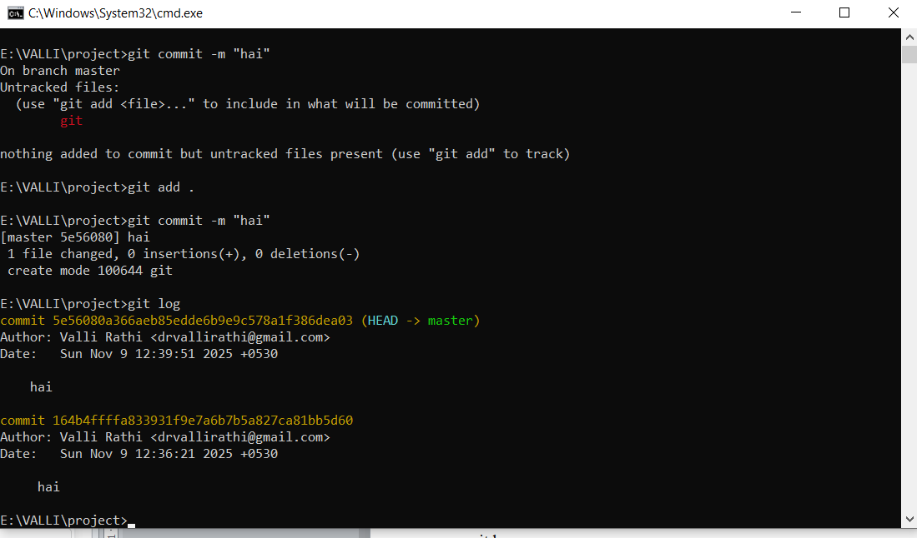

6. Create and Switch Branches
Create a new branch:
Syntax :git branch branch_name
Switch to that branch:
Syntax :git checkout branch_name
Or create and switch in one command:
Syntax :git checkout -b new_branch_name
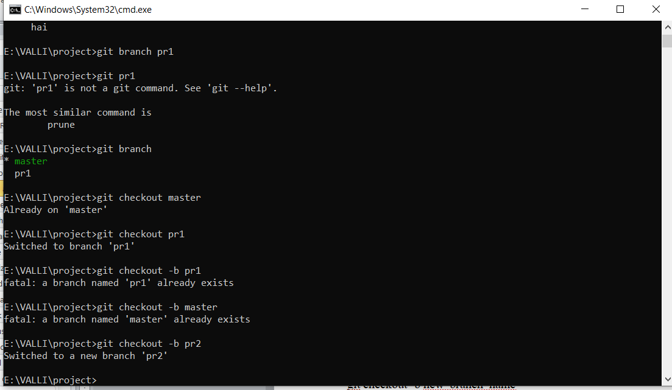

7. Connect to a Remote Repository
Syntax: git remote add origin https://github.com/username/repo-name.git
- Links your local repository to a remote GitHub repository.
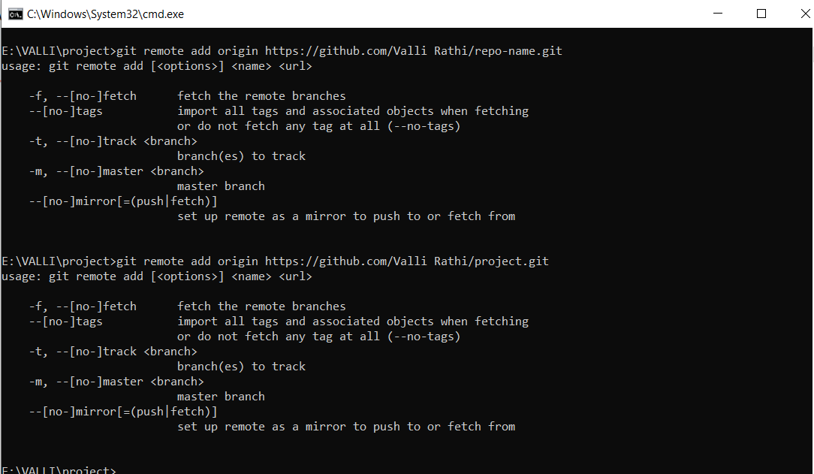

8. Push Changes to Remote
git push -u origin main
git push -u origin master

git remote set-url origin https://github.com/vallirathi/newone.git

git remote –v

- Pushes commits to the remote branch (main in this case).

9. Pull Changes from Remote
Syntax : git pull origin main

- Fetches and merges changes from the remote repository.

10. Clone an Existing Repository
git clone https://github.com/username/repo-name.git
- Creates a local copy of a remote repository.
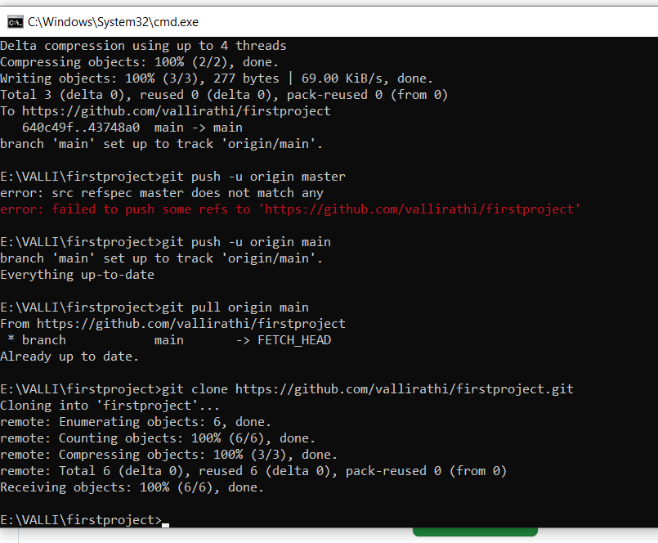
Expr2 :To link a local repository with GitHub and sync code.

Step 1: Initialize Git (if not done yet)
Open your terminal or Git Bash in your project folder and run:
git init
This command initializes a new Git repository in your local folder.

Step 2: Add and Commit Files
Add your files to the staging area:
git add .
Then commit them:
git commit -m "Initial commit"

Step 3: Create a New Repository on GitHub
- Go to https://github.com
- Click New Repository
- Enter a name (e.g., my-project)
- Do not select "Initialize with README" (you already have one locally)
- Click Create Repository

Step 4: Link Local Repo with GitHub
Copy the HTTPS URL of your GitHub repo (for example):
https://github.com/username/my-project.git
Now link your local repository to it:

git remote add origin https://github.com/username/my-project.git
git remote set-url origin https://github.com/vallirathi/newone.git

Check if the remote was added correctly:
git remote -v

Step 5: Push Local Code to GitHub
Push your local commits to the GitHub repository:
git branch -M main
git push -u origin main
- -u sets origin as the default remote.
- After this, you can simply use git push for future updates.

Step 6: Sync Changes (Push and Pull)

Push local changes to GitHub:
git add .
git commit -m "Updated project files"

git push -u origin master

git push

Pull latest changes from GitHub to local:
git pull

git pull origin main

✅Verification
- Go to your GitHub repository page.
- Refresh it — your files should appear.
- Every time you make changes locally, use:
- git add .
- git commit -m "message"
git push

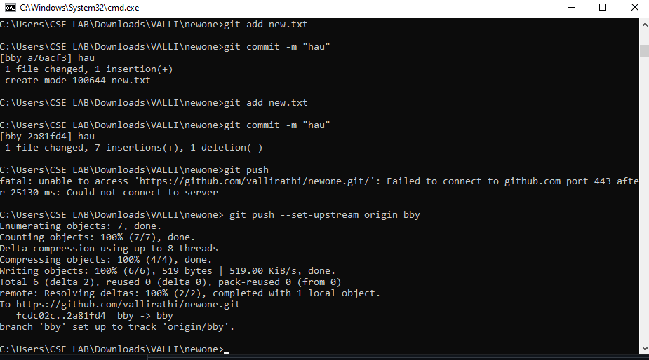

Check updates on GitHub
- Go to your repository page on GitHub — for example:
👉 https://github.com/vallirathi/newone
- Refresh the page.
- You’ll now see your updated file and the latest commit message (e.g., “Updated index.html with new content”).

git log

Expr.No : 3 To create and merge branches for feature development.

Creating and Merging Branches for Feature Development

Objective
To learn how to use Git branches for parallel feature development and how to merge them back into the main branch.

Prerequisites
- Git installed on your system
- A local Git repository already initialized (gitinit)
- At least one commit on the main branch

Step 1: Check Current Branch
Syntax : git branch
This command lists all branches in the repository and highlights the one you’re currently on (usually main).
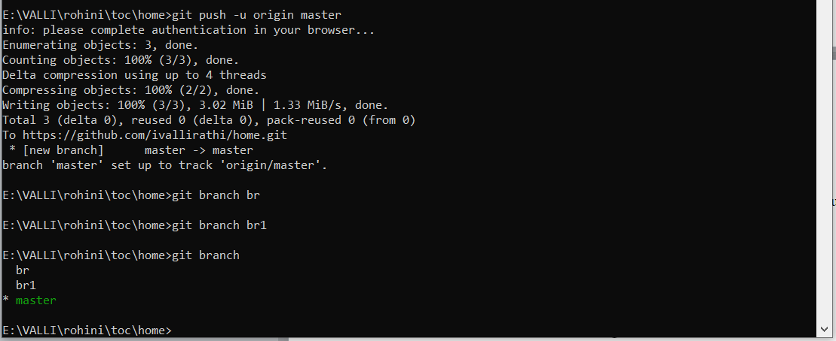

Step 2: Create a New Branch
Suppose you want to work on a new feature called “login-page”.
Syntax : git branch feature-login
This creates a new branch named feature-login.

Step 3: Switch to the New Branch
Syntax : git checkout feature-login
Now, you are in the feature-login branch.
You can confirm it using:
Syntax : git branch
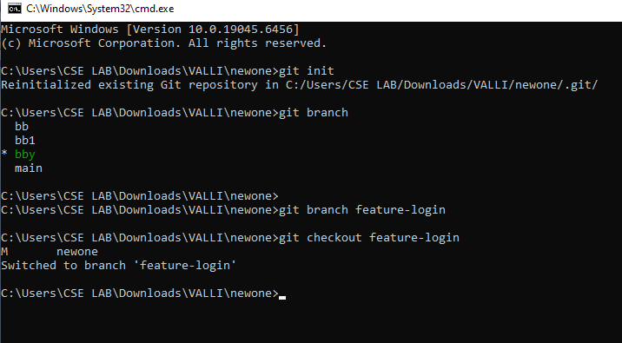

Step 4: Work on the Feature
Make your code changes (for example, add a new file):
echo"Login page code here"> login.html
Stage and commit your changes:
Syntax : git add login.html
Syntax : git commit -m "Added login page feature"

Step 5: Switch Back to the Main Branch
Syntax : git checkout main
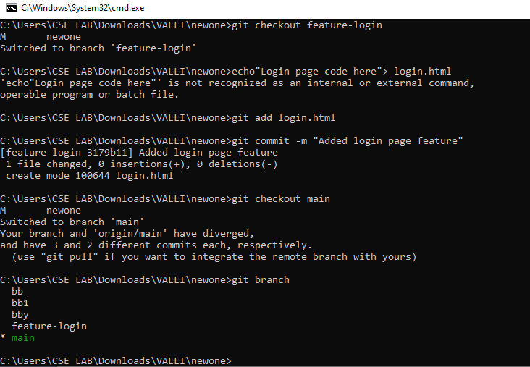

Step 6: Merge the Feature Branch into Main
Now, merge your feature branch changes into the main branch:
Syntax : git merge feature-login
Git will merge the commits from feature-login into main.
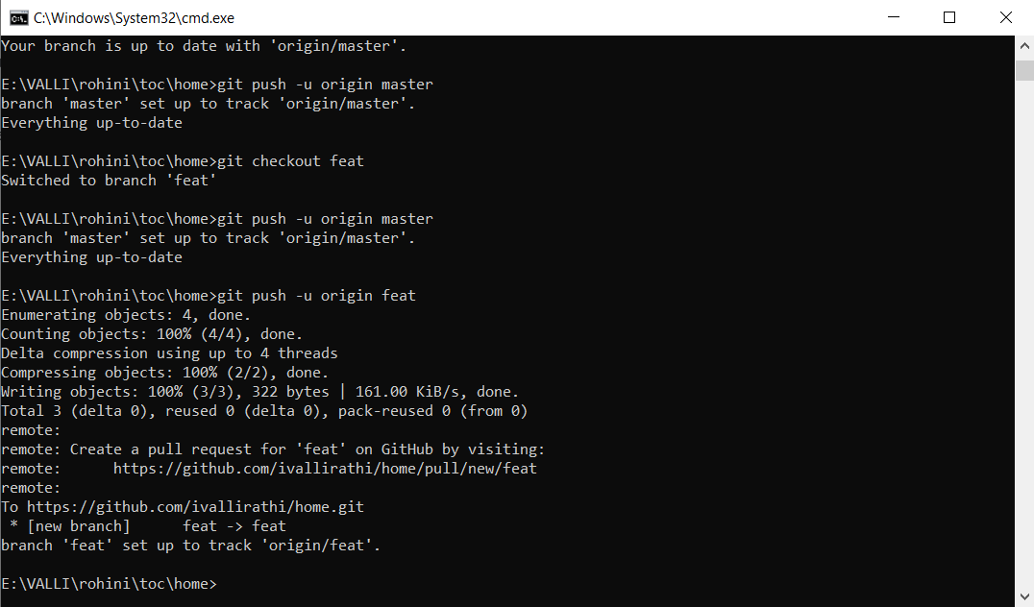

Step 7: Resolve Merge Conflicts (if any)
If two branches changed the same lines in a file, Git will show a merge conflict.
To fix:
- Open the file and manually edit conflict markers (<<<<<<<, =======, >>>>>>>)
- Save the file
- Then run:
- git add <filename>
- git commit

Step 8: Delete the Feature Branch (Optional)
Once merged, you can delete the feature branch to keep things clean:
git branch -d feature-login

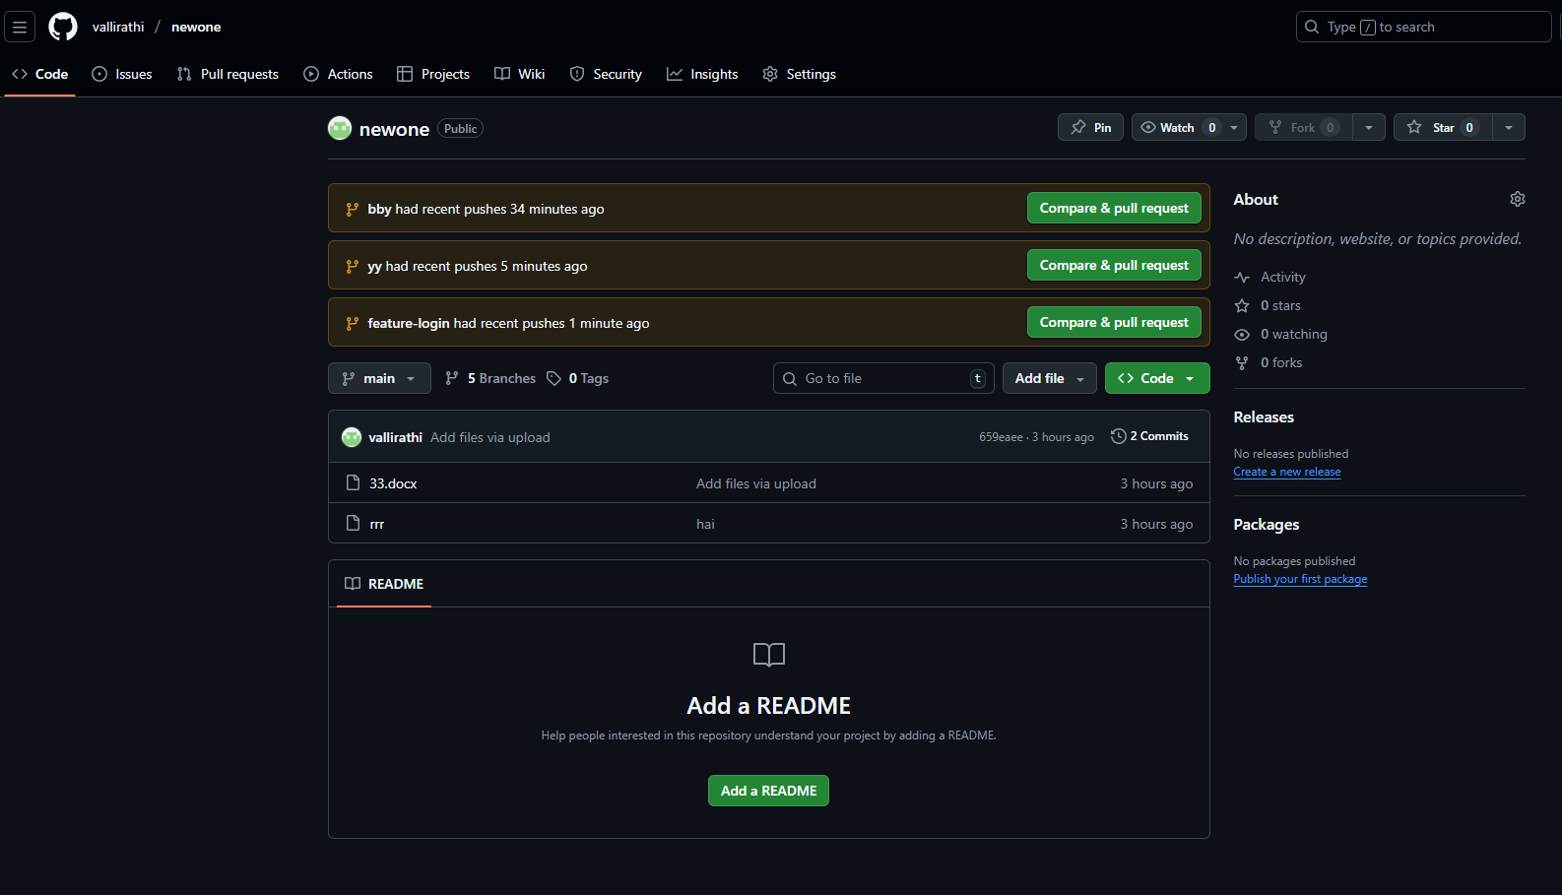

Expr.No 4: To collaborate via forks and pull requests.

Collaborating via Forks and Pull Requests

Objective
To learn how to contribute to another person’s (or organization’s) GitHub repository using forks and pull requests.

Prerequisites
- A GitHub account
- Basic knowledge of Git commands
- Access to a public repository you want to contribute to

Concept Overview
Term | Meaning
Fork | A personal copy of another user’s repository. You can modify it without affecting the original project.
Pull Request (PR) | A request to merge your changes from your forked repository into the original (main) repository.

Step 1: Fork the Original Repository
- Go to the GitHub repository you want to contribute to.
- Click the “Fork” button in the top-right corner.
- GitHub creates a copy of that repository in your own account.
✅ Example:
Original repo: https://github.com/originaluser/project
Your fork: https://github.com/yourusername/project

Step 2: Clone Your Fork to Local System
Now clone your forked repo to work on it locally:
gitclone https://github.com/yourusername/project.git
Syntax : git clone https://github.com/vallirathi/project.git

Syntax : cd project

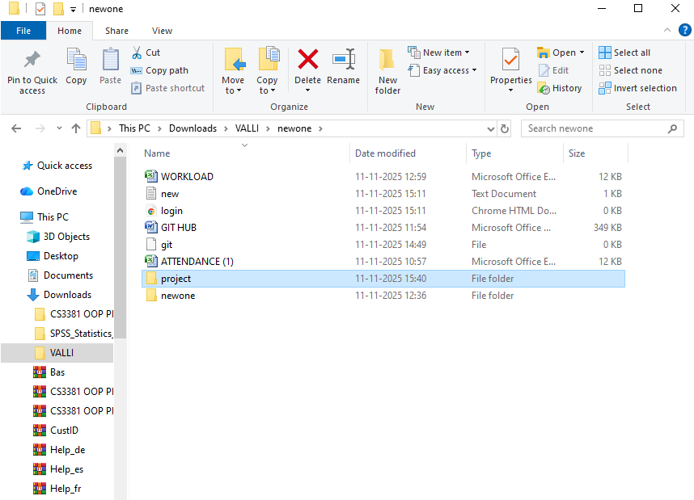

Step 3: Create a New Branch for Your Changes
It’s a good practice not to work directly on the main branch.
git checkout -b feature-update-readme
Syntax : git checkout -b feature-update-readme

Step 4: Make and Commit Your Changes
Edit or add files as needed, then stage and commit:
Syntax : git add .
Syntax : git commit -m "Improved README with setup instructions"

Step 5: Push the Branch to Your Fork
Syntax : git push origin feature-update-readme

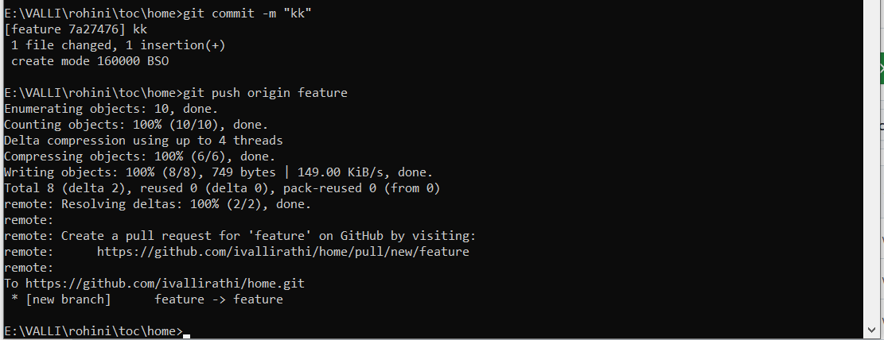

Step 6: Create a Pull Request (PR)
- Go to your forked repository on GitHub.
- You’ll see a prompt like:
“Compare & pull request” → click it.
- Write a short title and description of your changes.
- Click Create Pull Request.
✅ This sends your changes for review to the original repository owner.
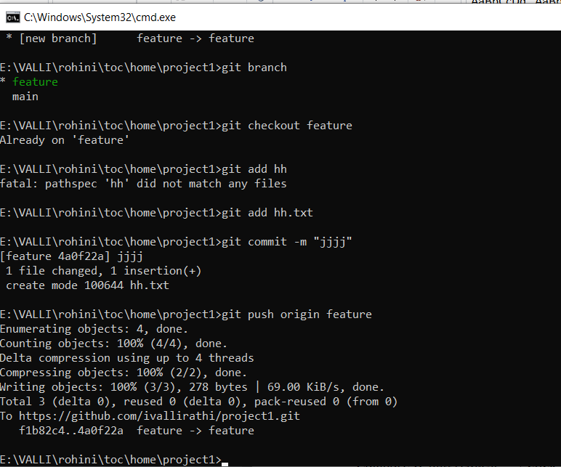

Step 7: Review and Merge
- The repository owner reviews your pull request.
- They can comment, request changes, or approve it.
- Once approved, the owner merges your changes into the main repository.

Step 8: Sync Your Fork with Original Repository
To keep your fork updated:
git remote add upstream https://github.com/originaluser/project.git
git fetch upstream
git checkout main
git merge upstream/main
git push origin main

Example Workflow
# Fork the repo on GitHub
git clone https://github.com/yourusername/project.git
cd project
git checkout -b fix-typo
# Edit a file (e.g., README.md)
git add README.md
git commit -m "Fixed typo in documentation"
git push origin fix-typo

- To create a basic GitHub Actions workflow.

Creating a Basic GitHub Actions Workflow

Objective
To understand how to automate tasks (like testing or building code) using GitHub Actions by creating a simple CI (Continuous Integration) workflow.

Prerequisites
- A GitHub account
- A Git repository on GitHub
- Basic knowledge of committing and pushing files

Concept Overview
GitHub Actions is a tool built into GitHub that helps automate tasks such as:
- Running tests automatically when code is pushed
- Building and deploying applications
- Sending notifications or running scripts
These tasks are defined in workflow files (YAML format) stored inside:
.github/workflows/

Step 1: Create a Workflow Directory
Inside your project folder, create the following folder structure:
.github/workflows/

Step 2: Create a Workflow File
Inside the folder, create a file named:
.github/workflows/main.yml

Step 3: Add a Basic Workflow Configuration
Example workflow file:
name:BasicCIWorkflow

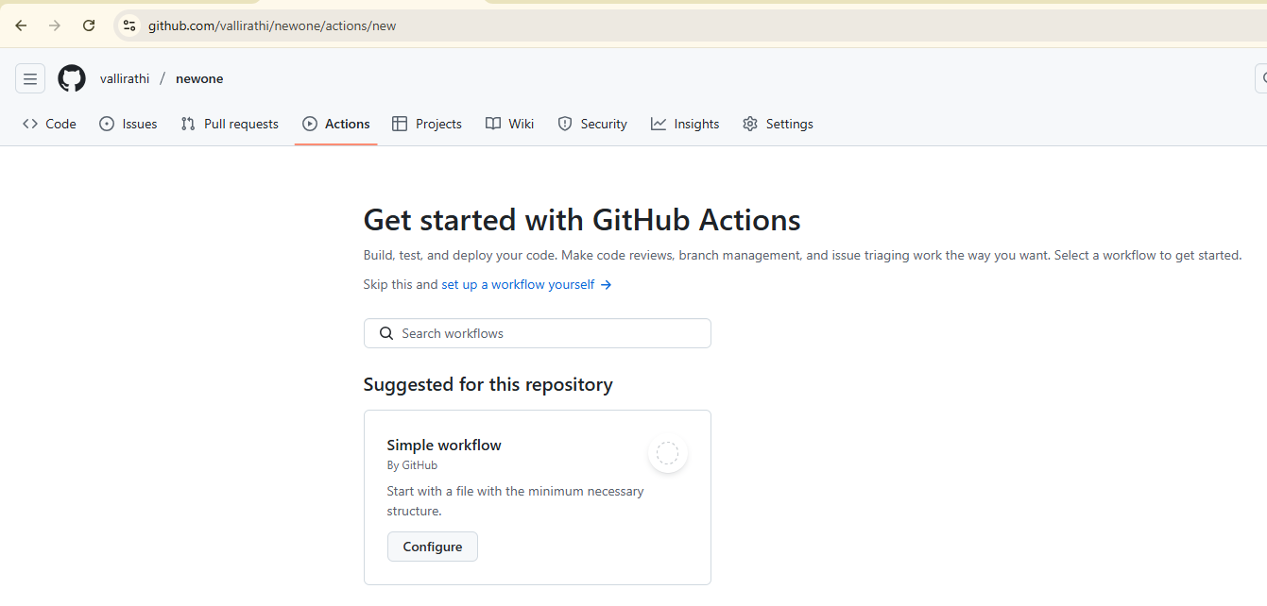

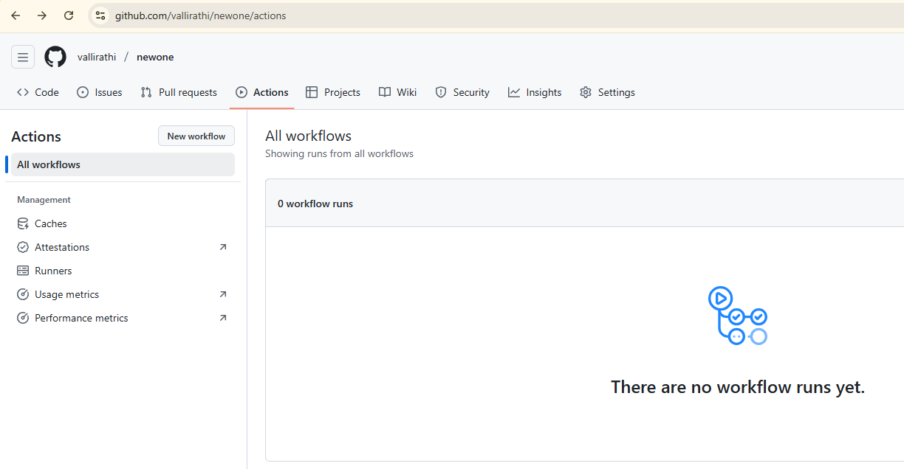

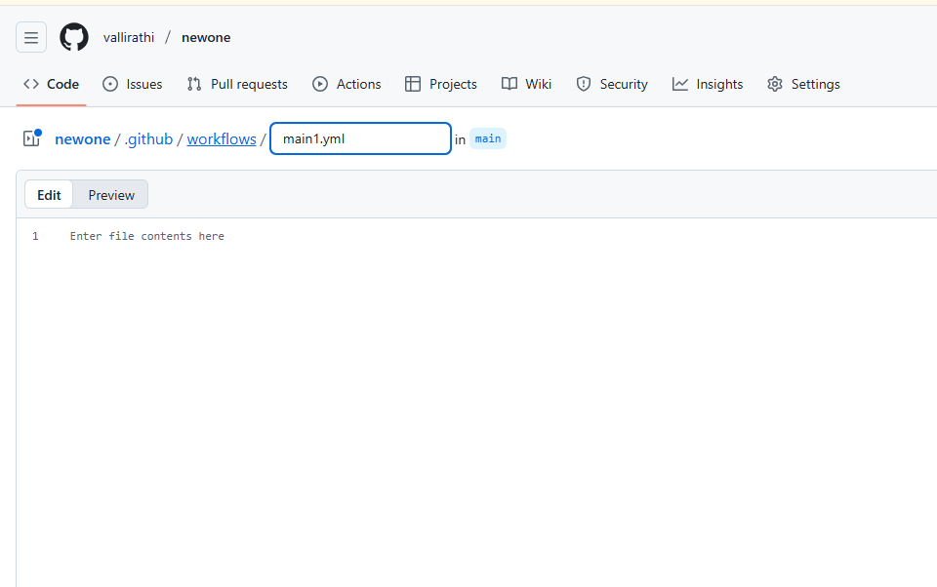
# When the workflow should run
on:
push:
branches: [ "main" ]
pull_request:
branches: [ "main" ]

# What jobs to run
jobs:
build:
runs-on:ubuntu-latest# Environment to run in

steps:
# Step 1: Checkout the code
-name:Checkoutrepository
uses:actions/checkout@v4

# Step 2: Run a simple command
-name:Displaymessage
run:echo" GitHub Actions workflow is running successfully!"

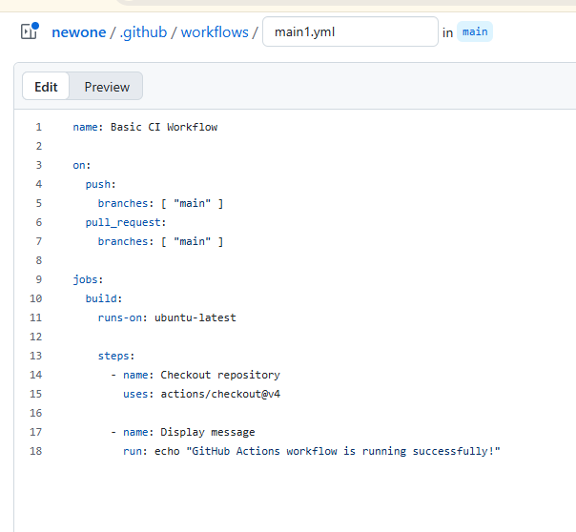

Step 4: Commit and Push the Workflow File
Syntax : git add .github/workflows/main1.yml
Syntax : git commit -m "Add basic GitHub Actions workflow"
Syntax : git push

Step 5: Verify the Workflow
- Go to your GitHub repository.
- Click on the “Actions” tab.
- You’ll see your workflow running automatically when you push changes.
- Once it finishes, you should see a green indicating success.

How It Works ( output )
Section | Purpose
name: | Name of your workflow
on: | Events that trigger the workflow (push, pull_request, etc.)
jobs: | Defines what the workflow will do
runs-on: | Virtual machine type (e.g., Ubuntu, Windows, macOS)
steps: | List of actions or commands to run

Optional – Example for Python Project
Here’s a simple Python test workflow example:
name:PythonTest

on: [push]

jobs:
test:
runs-on:ubuntu-latest
steps:
-uses:actions/checkout@v4
-name:SetupPython
uses:actions/setup-python@v5
with:
python-version:'3.11'
-name:Installdependencies
run:pipinstall-rrequirements.txt
-name:Runtests
run:pytest

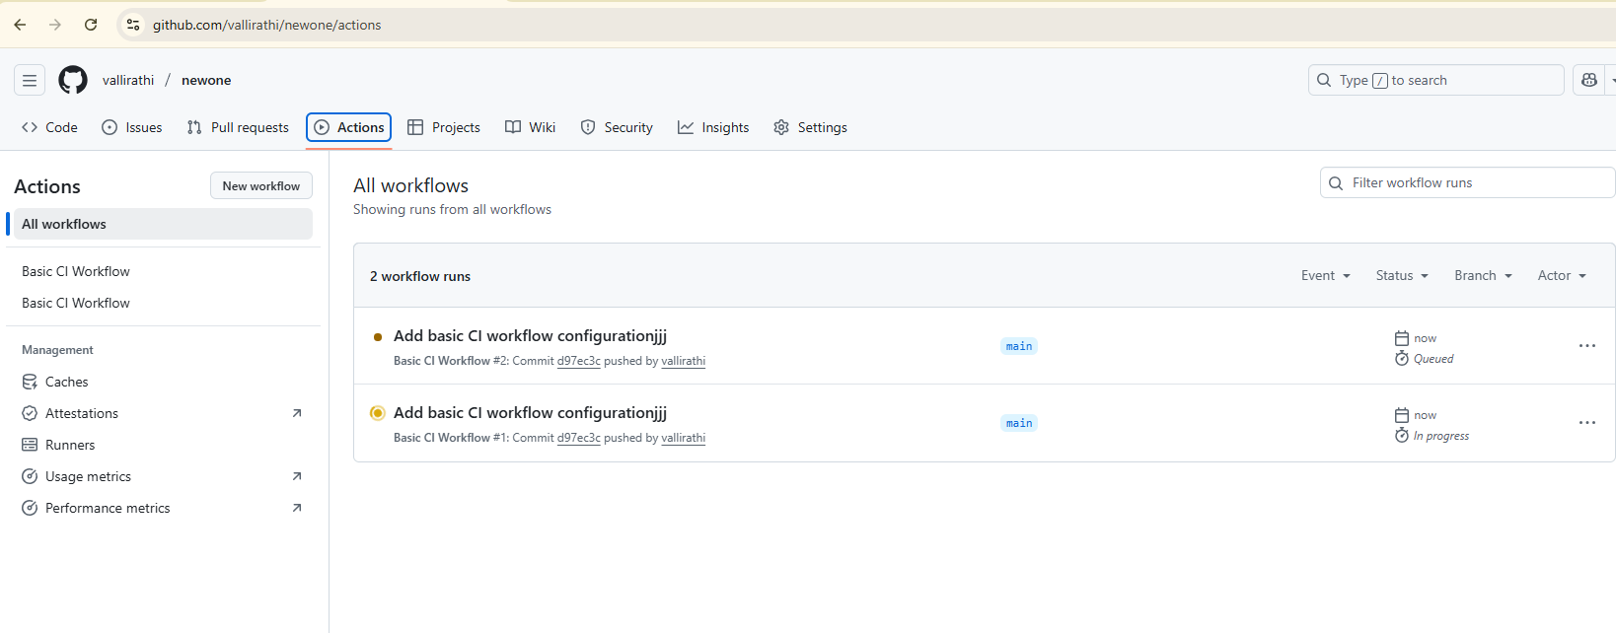
- To automate test runs using GitHub Actions.

Automating Test Runs Using GitHub Actions

Objective
To learn how to configure GitHub Actions to automatically run tests whenever code is pushed or a pull request is created ensuring code quality through continuous integration (CI).

Prerequisites
- A GitHub account
- A repository with some code (Python/Java/Node.js, etc.)
- Basic knowledge of Git commands and YAML syntax

Concept Overview
GitHub Actions can automatically:
- Run tests every time new code is pushed
- Detect errors early in the development process
- Improve collaboration and project reliability
Workflows are defined in YAML files stored in:
.github/workflows/

Step 1: Create a Project with Tests
For example, create a simple Python project:
File: calculator.py
defadd(a, b):
return a + b
File: test_calculator.py
from calculator import add

deftest_add():
assert add(2, 3) == 5

Step 2: Initialize Git and Push to GitHub
gitinit
git add .
git commit -m "Add calculator and test files"
git branch -M main
git remote add origin https://github.com/username/test-automation-demo.git
git push -u origin main

Step 3: Create the Workflow Directory and File
Inside your project, create:
.github/workflows/test.yml

Step 4: Define the Test Workflow
File: .github/workflows/test.yml
name:PythonTestAutomation

name: Python Test Automation

on:
push:
branches: [ "main" ]
pull_request:
branches: [ "main" ]

jobs:
test:
runs-on: ubuntu-latest

steps:
# Step 1: Checkout repository
- name: Checkout code
uses: actions/checkout@v4

# Step 2: Set up Python
- name: Setup Python
uses: actions/setup-python@v5
with:
python-version: '3.11'

# Step 3: Install dependencies
- name: Install dependencies
run: |
python -m pip install --upgrade pip
pip install pytest

# Step 4: Run test suite
- name: Run test suite
run: pytest

Step 5: Commit and Push the Workflow
git add .github/workflows/test.yml
git commit -m "Add GitHub Actions workflow for automated testing"
git push

Step 6: View Workflow Execution
- Go to your GitHub repository.
- Click on the “Actions” tab.
- You’ll see your Python Test Automation workflow running automatically.
- If the tests pass, it shows a ✅ green checkmark.
- If a test fails, it shows a ❌ and detailed logs.

How It Works
Section | Purpose
on: | Defines when the workflow triggers (push, PR, etc.)
jobs: | Defines what processes to run
runs-on: | The environment (e.g., Ubuntu)
steps: | The list of actions (checkout, install, test)
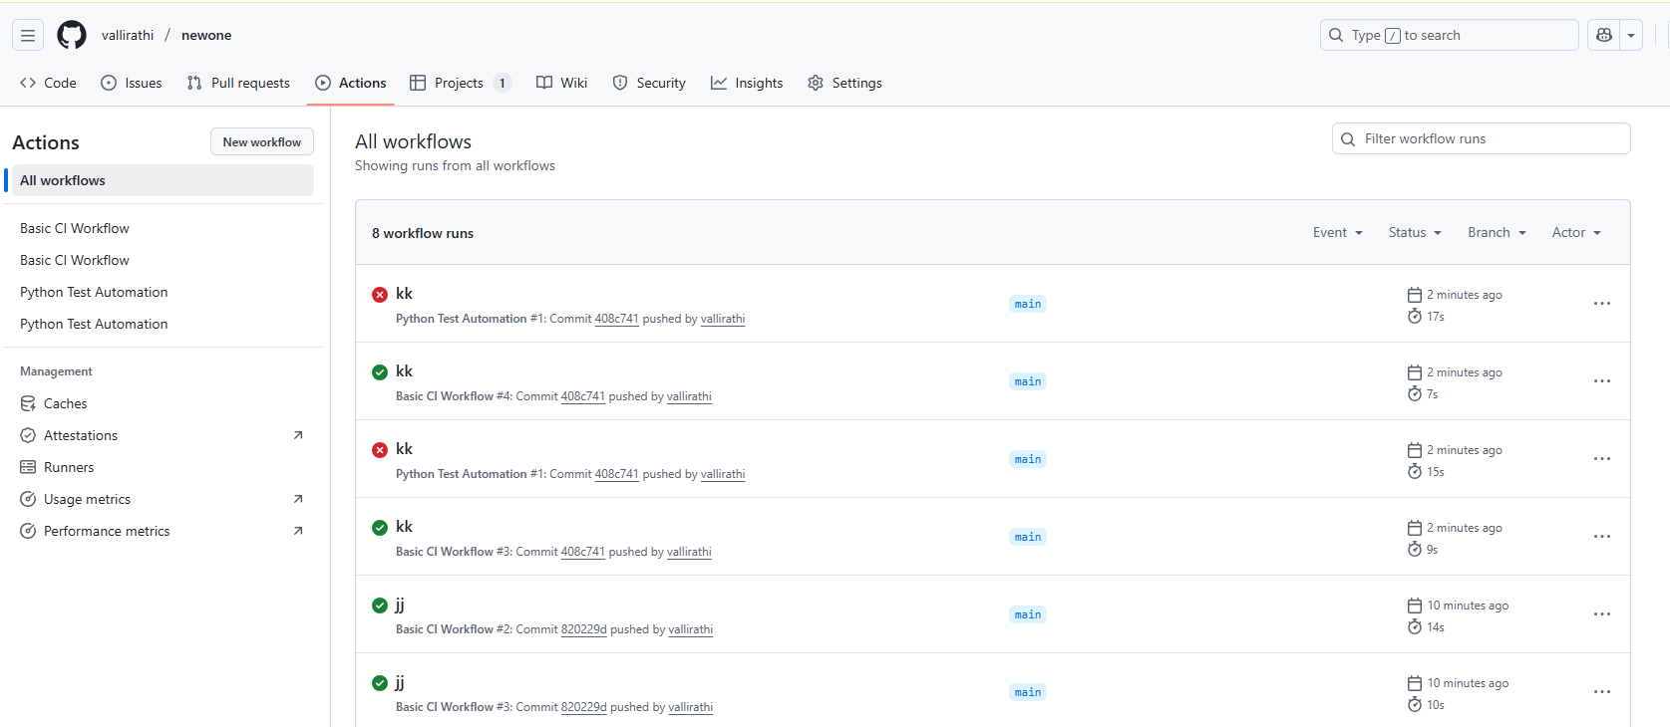

Example Output
In the Actions log, you’ll see:
============================== test session starts ==============================
collected 1 item
test_calculator.py .

- To use secrets in GitHub Actions securely.

Using Secrets in GitHub Actions Securely

Objective
To understand how to securely store and use sensitive information (like API keys, tokens, or passwords) in GitHub Actions workflows using GitHub Secrets.

Prerequisites
- A GitHub account
- A repository with a workflow setup
- Basic knowledge of YAML and GitHub Actions

Concept Overview
GitHub Actions allow you to store sensitive information (like credentials, access tokens, API keys) as secrets in a secure way.
These secrets are encrypted and hidden in logs during workflow runs.
Examples of secrets:
- API keys (API_KEY)
- Cloud credentials (AWS_ACCESS_KEY_ID, AWS_SECRET_ACCESS_KEY)
- Database passwords (DB_PASSWORD)

Step 1: Add a Secret in GitHub
- Open your repository on GitHub.
- Go to Settings → Secrets and variables → Actions → New repository secret
- Click “New repository secret”
- Enter:
  - Name:MY_SECRET_KEY
  - Value:12345-abcde-67890
- Click Add secret
✅ GitHub securely encrypts this value.

Step 2: Create a Workflow that Uses the Secret
Inside your project folder, create or edit this file:
.github/workflows/secrets-demo.yml
File: .github/workflows/secrets-demo.yml
name:UsingSecretsDemo

on:
push:
branches: [ "main" ]

jobs:
demo:
runs-on:ubuntu-latest

steps:
-name:Checkoutrepository
uses:actions/checkout@v4

-name:Accesssecretvalue
run:echo"The secret key is ${{ secrets.MY_SECRET_KEY }}"

Step 3: Protect the Secret in Logs
When the workflow runs, GitHub automatically masks the secret value in logs.
Even if you try to print it, you’ll see:
The secret keyis ***
✅ This ensures the secret is never exposed publicly.

Step 4: Use Secrets in Environment Variables
You can pass secrets to your environment variables safely:
-name:Usesecretinenvironment
env:
SECRET_KEY:${{secrets.MY_SECRET_KEY}}
run:|
echo "Using secret in environment"
echo "SECRET_KEY is $SECRET_KEY"
(Still, the value will be masked in logs.)

Step 5: Best Practices
✅Do’s
- Use secrets for all sensitive credentials.
- Store secrets at the repository or organization level.
- Use environment variables to reference secrets within steps.
❌Don’ts
- Never hardcode secrets in code or workflows.
- Don’t print secrets directly to the logs.
- Avoid using secrets in if conditions (they might leak via log evaluation).

Example: Using Secrets for API Authentication
name:APIRequestwithSecret

on: [push]

jobs:
api_call:
runs-on:ubuntu-latest
steps:
-name:Checkoutcode
uses:actions/checkout@v4

-name:MakeAPIrequest
env:
API_KEY:${{secrets.MY_SECRET_KEY}}
run:|
curl -H "Authorization: Bearer $API_KEY" https://api.example.com/data

- To deploy a static site via CI/CD pipeline.

Deploying a Static Site via CI/CD Pipeline

Objective
To automate the deployment of a static website using GitHub Actions, implementing a basic CI/CD (Continuous Integration and Continuous Deployment) pipeline.

Prerequisites
- A GitHub account
- A static website (HTML/CSS/JS files)
- A GitHub repository
- Basic knowledge of Git commands and GitHub Actions

Concept Overview
CI/CD pipeline automates:
- Continuous Integration (CI): Testing and building code automatically after changes.
- Continuous Deployment (CD): Automatically deploying updates to a live environment.
GitHub Actions helps you automate this entire process directly from your GitHub repository.
For static sites, you can deploy easily using GitHub Pages.

Step 1: Create a Static Website
Create a simple website in your local folder.
File: index.html
<!DOCTYPE html>
<html>
<head>
<title>My CI/CD Demo</title>
</head>
<body>
<h1>Hello from GitHub Actions CI/CD!</h1>
<p>This site is deployed automatically.</p>
</body>
</html>

Step 2: Initialize Git and Push to GitHub
gitinit
git add .
git commit -m "Initial static site files"
git branch -M main
git remote add origin https://github.com/username/static-site-demo.git
git push -u origin main

Step 3: Create a GitHub Actions Workflow
Inside your project folder, create the directory:
.github/workflows/
Then create a workflow file:
.github/workflows/deploy.yml

Step 4: Add the Deployment Workflow
File: .github/workflows/deploy.yml
name:DeployStaticSite

on:
push:
branches: [ "main" ] # Runs when code is pushed to main

permissions:
contents:write

jobs:
deploy:
runs-on:ubuntu-latest

steps:
-name:CheckoutRepository
uses:actions/checkout@v4

-name:DeploytoGitHubPages
uses:peaceiris/actions-gh-pages@v4
with:
github_token:${{secrets.GITHUB_TOKEN}}
publish_dir:./

Step 5: Commit and Push the Workflow
git add .github/workflows/deploy.yml
git commit -m "Add CI/CD workflow for static site"
git push

Step 6: Enable GitHub Pages Deployment
- Go to your GitHub repository → Settings → Pages
- Under Build and deployment → Source, select GitHub Actions
- Wait for the workflow to finish running
- Your site will be live at:
- https://username.github.io/static-site-demo/

How It Works
Step | Purpose
on: push | Triggers the workflow when changes are pushed to main
actions/checkout | Checks out your repository code
peaceiris/actions-gh-pages | Deploys the website to GitHub Pages automatically
secrets.GITHUB_TOKEN | Authenticates the deployment securely

Step 7: Test the CI/CD Pipeline
- Modify the index.html file (e.g., change the text).
- Commit and push again:
- git add index.html
- git commit -m "Updated homepage content"
- git push
- GitHub Actions will automatically redeploy your updated site!

- To build a Docker image in a GitHub Actions workflow.

Experiment: To Build a Docker Image in a GitHub Actions Workflow

Objective
To automate the process of building a Docker image using GitHub Actions whenever code is pushed to a repository.

Prerequisites
- A GitHub account
- Dockerfile in your repository
- GitHub Actions enabled on your repository

Concept Overview
Docker is a containerization platform that packages applications and dependencies into lightweight containers.
GitHub Actions can automatically:
- Build Docker images on every code push
- Test and validate builds
- Optionally push the image to a Docker registry like Docker Hub or GitHub Container Registry (GHCR)

Step 1: Create a Simple Dockerfile
Create a file named Dockerfile in your repository:
# Use official Node.js image as base
FROM node:18-alpine

# Set working directory
WORKDIR /app

# Copy package.json and install dependencies
COPY package*.json ./
RUN npm install

# Copy all files to container
COPY . .

# Expose port
EXPOSE 3000

# Run the application
CMD ["npm", "start"]

Step 2: Commit and Push the Dockerfile
git add Dockerfile
git commit -m "Add Dockerfile for CI/CD build"
git push

Step 3: Create a GitHub Actions Workflow
Inside your repo, create this path:
.github/workflows/docker-build.yml

Step 4: Add Workflow Configuration
File: .github/workflows/docker-build.yml
name:BuildDockerImage

on:
push:
branches: [ "main" ] # Trigger when code is pushed to main branch

jobs:
build:
runs-on:ubuntu-latest

steps:
-name:Checkoutcode
uses:actions/checkout@v4

-name:SetupDockerBuildx
uses:docker/setup-buildx-action@v3

-name:BuildDockerimage
run:dockerbuild-tmyapp:latest.

⚙️(Optional) Step 5: Push Image to Docker Hub
If you want to push the image to Docker Hub, update your workflow:
name:BuildandPushDockerImage

on:
push:
branches: [ "main" ]

jobs:
build:
runs-on:ubuntu-latest

steps:
-name:Checkoutcode
uses:actions/checkout@v4

-name:LogintoDockerHub
uses:docker/login-action@v3
with:
username:${{secrets.DOCKERHUB_USERNAME}}
password:${{secrets.DOCKERHUB_TOKEN}}

-name:BuildandPushDockerimage
uses:docker/build-push-action@v5
with:
push:true
tags:${{secrets.DOCKERHUB_USERNAME}}/myapp:latest

Set Secrets in GitHub
- Go to your repository → Settings → Secrets and variables → Actions
- Add:
  - DOCKERHUB_USERNAME
  - DOCKERHUB_TOKEN (you can generate this from your Docker Hub account under Security → Access Tokens)

Step 6: Verify Workflow
After pushing, go to:
GitHub → Repository → Actions tab
You’ll see a workflow run titled “Build Docker Image”.
If successful, it means your Docker image was built automatically by GitHub Actions.

To Build a Jenkins Job Triggered by GitHub Webhook

🎯Objective
To configure a Jenkins CI/CD job that automatically builds whenever code is pushed to a GitHub repository, using webhooks for triggering.

🧰Prerequisites
Before you begin, ensure that you have:
- Jenkins installed and running (locally or on a server)
- GitHub account with a sample repository
- Git plugin and GitHub Integration plugin installed in Jenkins
- Internet access for GitHub → Jenkins communication

📘Concept Overview

🔹Jenkins
Jenkins is an open-source automation tool used for building, testing, and deploying code.

🔹Webhook
A webhook is an HTTP callback that sends data to a URL when an event occurs.
Here, GitHub notifies Jenkins automatically when new code is pushed — triggering a build.

⚙️Step 1: Create a Sample GitHub Repository
- Go to GitHub → New Repository
- Name it something like: jenkins-webhook-demo
- Add a sample file, e.g., index.html
- Commit and push changes.

⚙️Step 2: Configure Jenkins
- Open Jenkins Dashboard → Manage Jenkins → Plugins → Available Plugins
- Install these plugins:
  - Git Plugin
  - GitHub Plugin
  - GitHub Integration Plugin
- Restart Jenkins after installation.

⚙️Step 3: Create a New Jenkins Job
- Go to Jenkins Dashboard → New Item
- Enter job name: GitHub-Webhook-Build
- Select Freestyle project → Click OK

🧩Step 4: Configure Source Code Management
- Under Source Code Management, choose Git
- In the Repository URL, enter your GitHub repo link:
- https://github.com/username/jenkins-webhook-demo.git
- If the repository is private, add credentials.
- Branch to build:
- */main

⚙️Step 5: Set Up GitHub Trigger
- Under Build Triggers, select:
✅GitHub hook trigger for GITScm polling
This means Jenkins will start a build when GitHub sends a webhook notification.

⚙️Step 6: Add a Build Step
- Under Build, click Add build step → Execute shell
- Add a simple command, for example:
- echo"Building project triggered by GitHub webhook"
- echo"Code from $(pwd)"
- ls -l

🖥️Step 7: Configure GitHub Webhook
- Go to your GitHub repository → Settings → Webhooks → Add webhook
- In Payload URL, enter your Jenkins URL followed by /github-webhook/
Example:
- http://<your-jenkins-ip>:8080/github-webhook/
- Content type:application/json
- Event type: Choose Just the push event
- Click Add Webhook

Step 8: Test the Setup
- Go to your GitHub repo
- Make a small change (e.g., edit index.html)
- Commit and push the change
➡️ Jenkins will automatically detect the push and start the build!
You can verify the trigger in:
- Jenkins Dashboard → Build History
- Console Output for the job log

Expected Output
- A new Jenkins build starts automatically after every GitHub push.
- Build logs show messages like:
- Started by GitHub push by username
Building project triggered by GitHub webhook

- To analyze and fix failing CI workflows.

To Analyze and Fix Failing CI Workflows

Objective
To identify, analyze, and fix issues in Continuous Integration (CI) workflows using GitHub Actions, ensuring smooth automation of builds and tests.

Prerequisites
- A GitHub repository with a CI workflow (e.g., build.yml or test.yml)
- Basic understanding of GitHub Actions syntax
- A failing or error-prone workflow (for testing purposes)

Concept Overview

Continuous Integration (CI)
CI automatically builds and tests your code every time you commit changes — catching errors early.

Why Workflows Fail
Common causes of workflow failure:
- Incorrect YAML syntax
- Missing dependencies or paths
- Failed build/test commands
- Permission or authentication errors
- Environment setup issues
Analyzing logs helps pinpoint and fix these issues efficiently.

Step 1: Create a Failing Workflow (for practice)
Inside your repo, create:
.github/workflows/test.yml
File: .github/workflows/test.yml
name:SampleCIWorkflow

on:
push:
branches: [ "main" ]

jobs:
build:
runs-on:ubuntu-latest
steps:
-name:CheckoutRepository
uses:actions/checkout@v4

-name:Runabrokencommand
run:npminstal# ❌ Intentional typo (should be 'install')
Push this workflow to your GitHub repository.
git add .github/workflows/test.yml
git commit -m "Add failing CI workflow"
git push

Step 2: Observe the Workflow Failure
- Go to your GitHub repository → Actions tab
- Click the failed workflow run
- Click “build” under jobs to see the logs
You will see an error similar to:
Error: Command'npminstal' not found.

Step 3: Analyze the Failure

Typical failure categories:
Error Type | Cause | Example
Syntax Error | Wrong indentation or YAML format | Misplaced spaces
Dependency Error | Missing or incorrect packages | npminstal typo
Path Error | File not found | Missing script file
Permission Error | Missing token or rights | Deploying to Pages
Runtime Error | Failed test or script | Test assertion failed

Step 4: Fix the Error
Edit the workflow to correct the command:
-name:Runnpminstall
run:npminstall
Commit and push the fix:
git add .github/workflows/test.yml
git commit -m "Fix npm command in CI workflow"
git push

🔁Step 5: Re-run the Workflow
Once pushed, GitHub Actions will:
- Automatically trigger a new build
- Run successfully without errors
Check Actions → Workflow run → build logs to confirm.
Expected output:
added50 packages
found 0 vulnerabilities

Step 6: General Debugging Techniques
Issue | Fix / Action
Workflow doesn’t trigger | Check on: events and branch names
YAML syntax errors | Validate with YAML Lint
Missing dependencies | Add installation steps before running commands
Permission denied | Use GITHUB_TOKEN or personal access token
Environment errors | Use correct OS (e.g., ubuntu-latest) and versions

12. To design and implement a full CI/CD pipeline.

